Urban Hive – UI Wireframes (Screen-Wise)

1. Landing Page (Public)

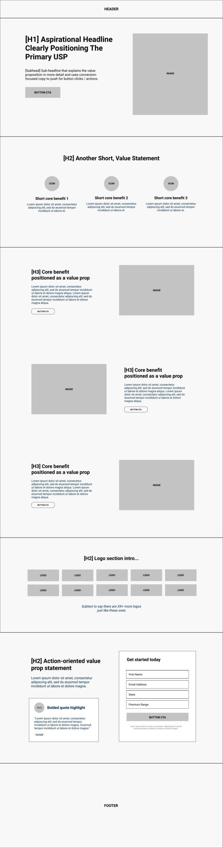
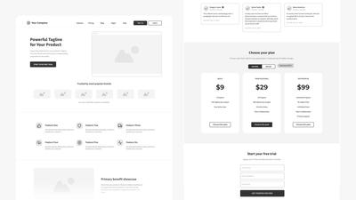

Layout Wireframe
------------------------------------------------
| LOGO | Home | Features | About | Login |
------------------------------------------------
| |
| SMART URBAN LIVING, SIMPLIFIED |
| Report issues • Find services • Stay aware |
| |
| [ Get Started ] [ Login ] |
| |
------------------------------------------------
| Feature 1 | Feature 2 | Feature 3 |
------------------------------------------------
| Footer (Contact | Social | Credits) |
------------------------------------------------

Purpose
- First impression
- Explains what Urban Hive does
- Entry point for login/register

Backend Dependency
❌ None (Static page)

2. Login Page
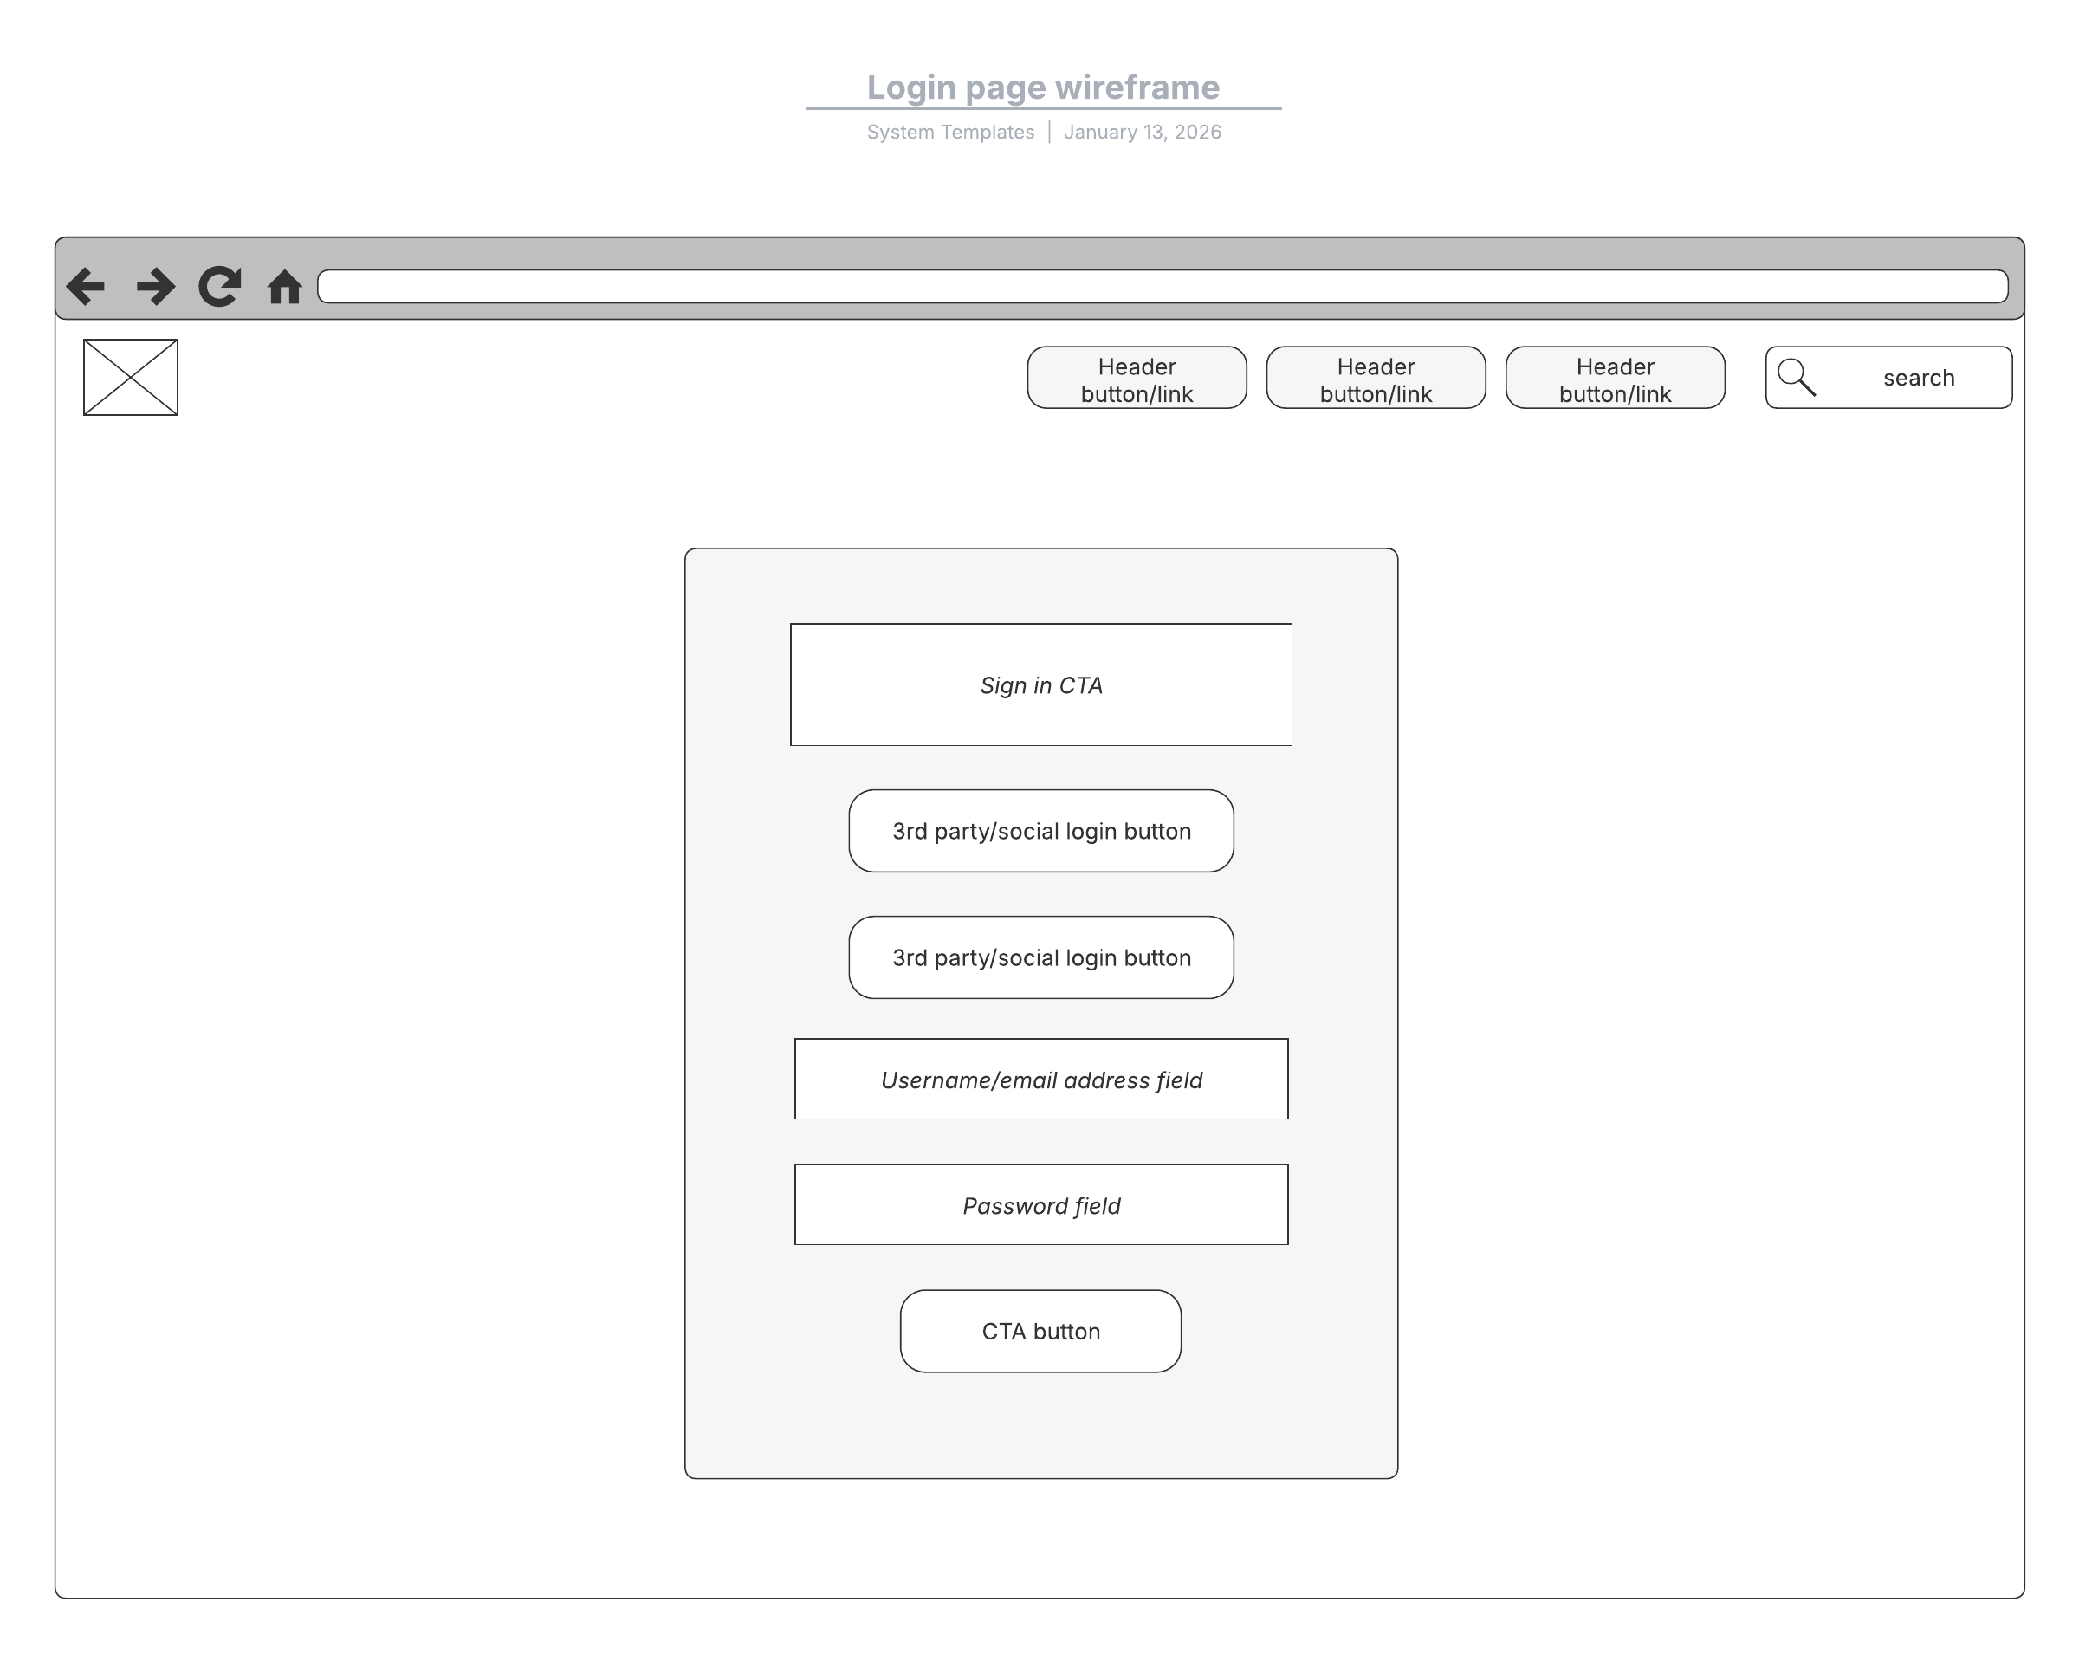

Layout Wireframe
------------------------------
| Urban Hive Logo |
------------------------------
| Email / Username |
| [____________________] |
| Password |
| [____________________] |
| |
| [ Login ] |
| |
| New user? Register |
------------------------------

Purpose
- User authentication
- JWT token generation

Backend Dependency
✔ /api/login

3. Register Page
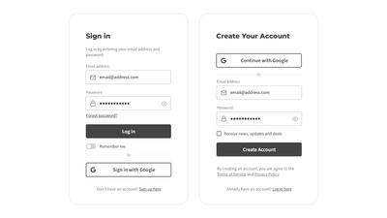

Layout Wireframe
--------------------------------
| Urban Hive Logo |
--------------------------------
| Full Name |
| Email |
| Password |
| Role: ( Citizen / Provider ) |
| City / Area |
| |
| [ Register ] |
--------------------------------

Purpose
- New user onboarding
- Role-based registration

Backend Dependency
✔ /api/register

4. User Dashboard (Citizen)
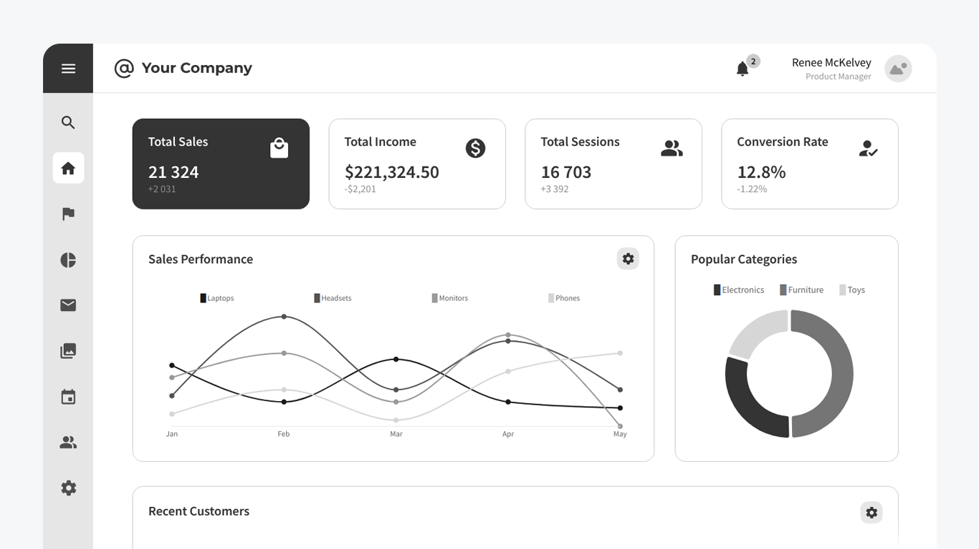
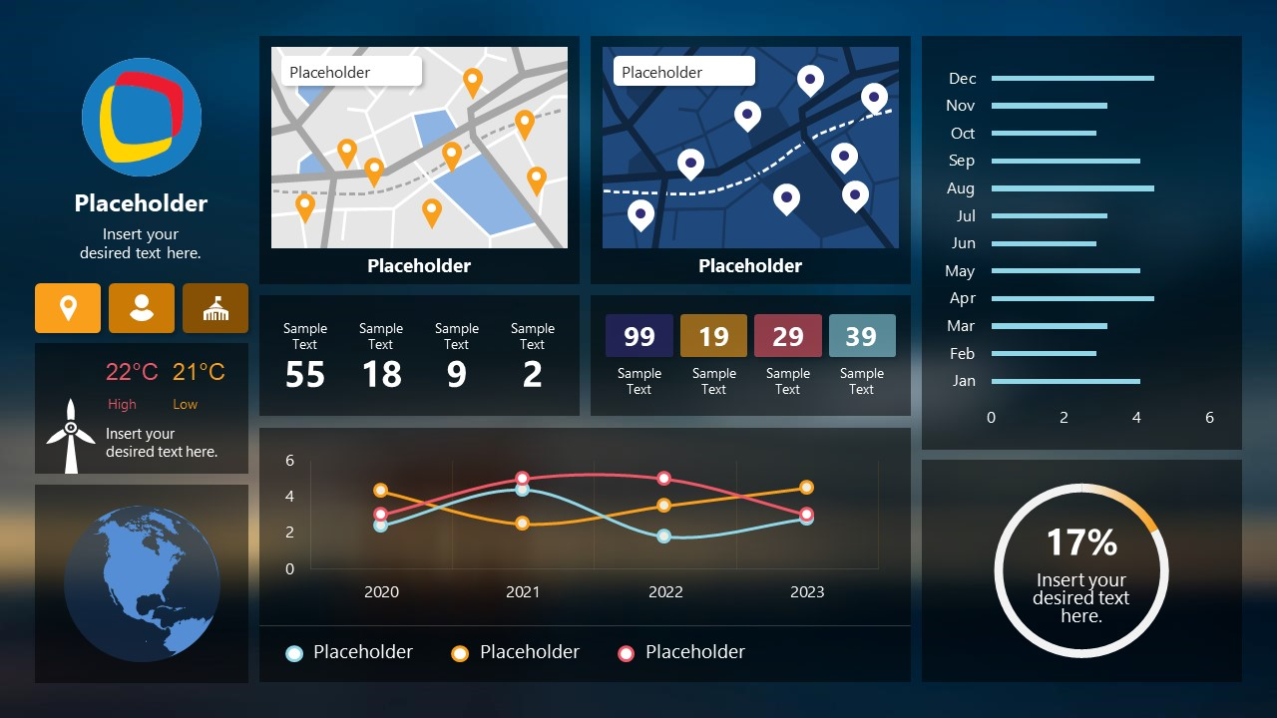
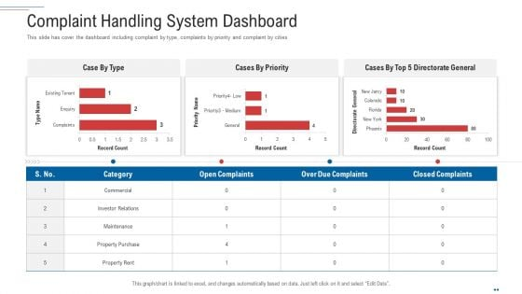

Layout Wireframe
------------------------------------------------
| Logo | Dashboard | Services | Profile | Logout|
------------------------------------------------
| Sidebar | Main Content |
|--------------------|--------------------------|
| • My Requests | Welcome, User 👋 |
| • New Complaint |--------------------------|
| • Notifications | Active Requests |
| • History | - Garbage Pickup (Open) |
| | - Water Issue (Resolved) |
| |--------------------------|
| | Nearby Services |
------------------------------------------------

Purpose
- Central control for citizens
- Request tracking & notifications

Backend Dependency
✔ /api/user/dashboard
✔ /api/complaints

5. New Complaint / Service Request Page

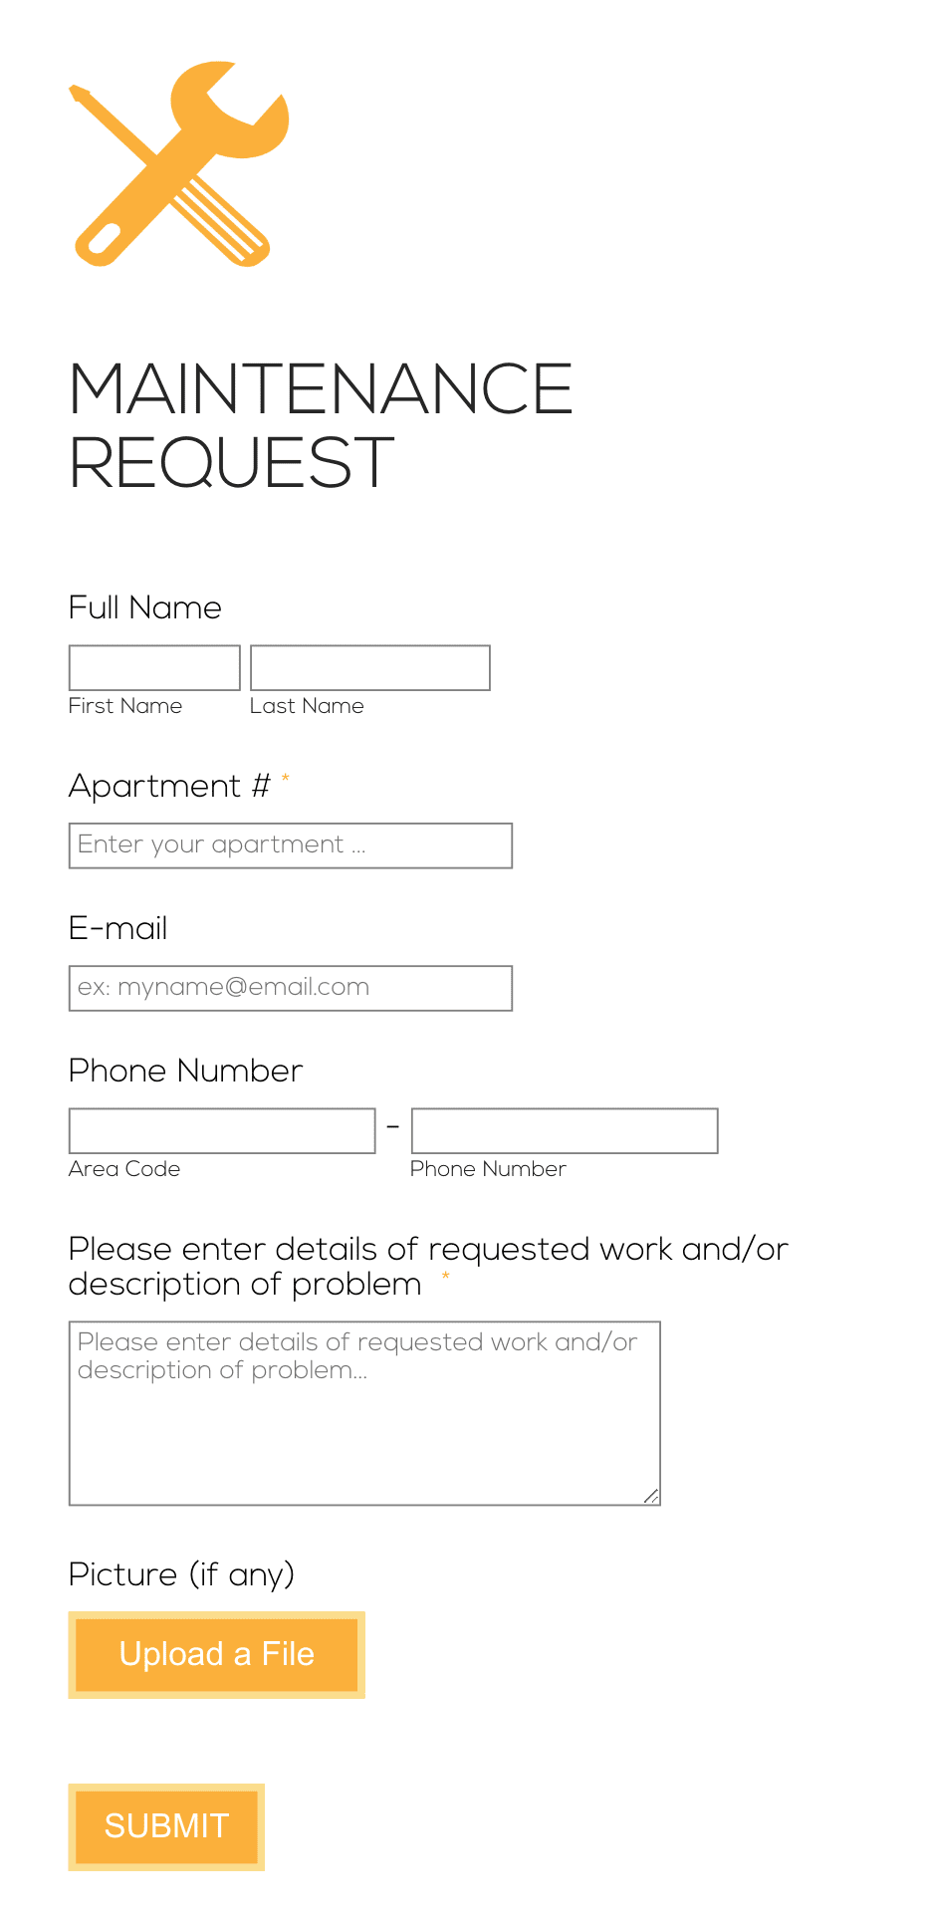

Layout Wireframe
------------------------------------
| Raise New Complaint |
------------------------------------
| Category (Water/Road/Garbage) |
| Description |
| Upload Image (optional) |
| Location (Auto / Manual) |
| |
| [ Submit Request ] |
------------------------------------

Purpose
- Core functionality of Urban Hive
- Data creation point

Backend Dependency
✔ /api/complaint/create

6. Service Provider Dashboard
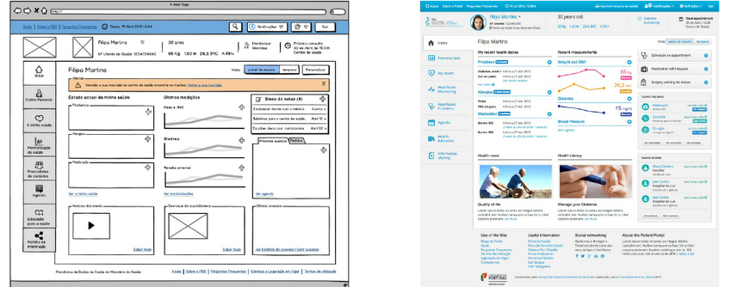
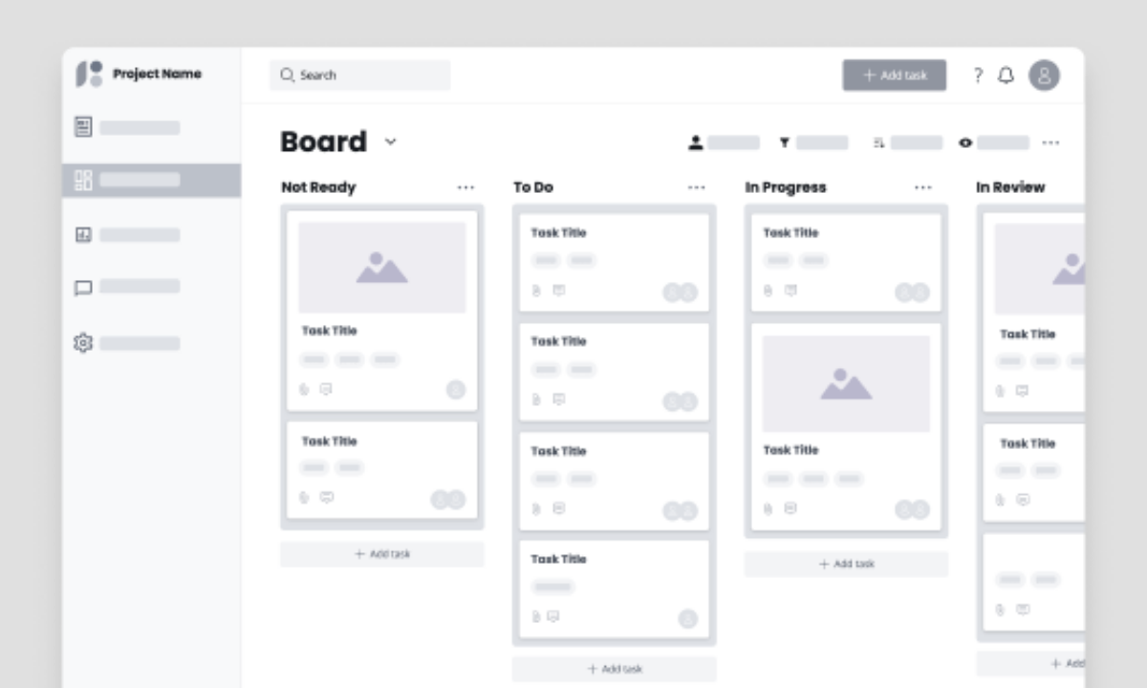
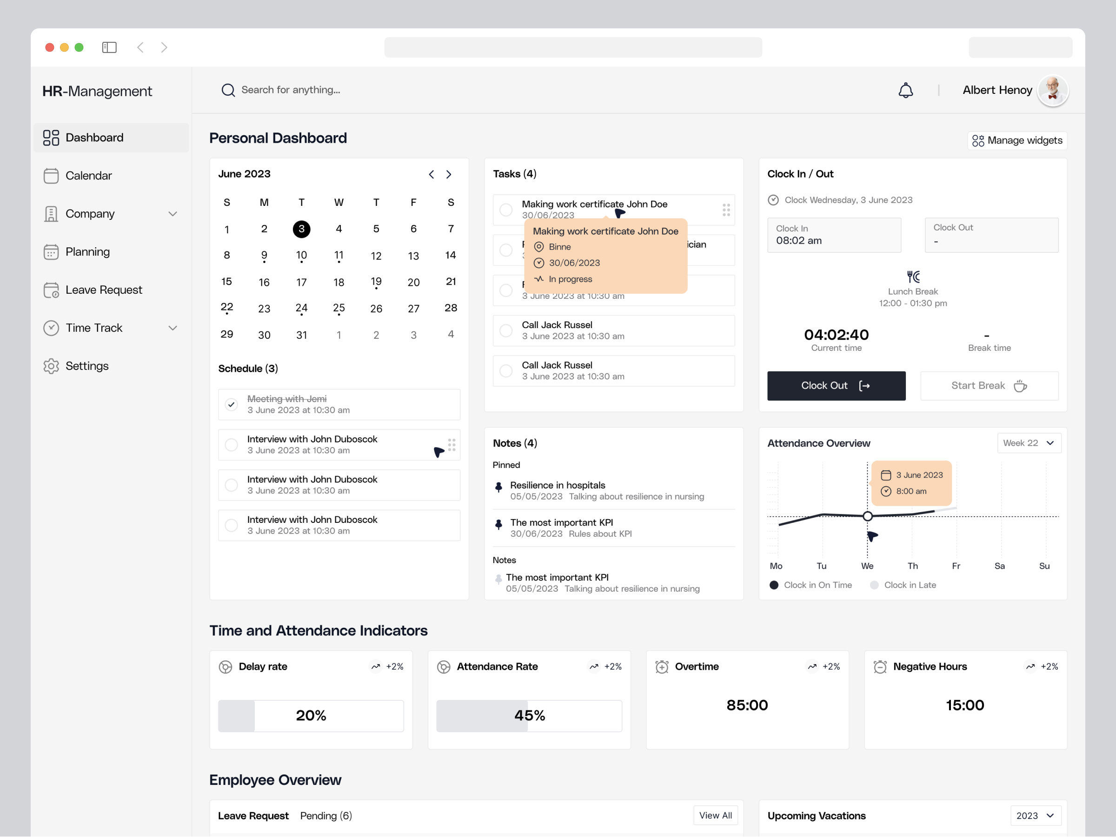

Layout Wireframe
------------------------------------------------
| Logo | Tasks | History | Profile | Logout |
------------------------------------------------
| Assigned Tasks |
|----------------------------------------------|
| Complaint ID | Location | Status | Action |
| 1023 | Sector 5 | Open | View |
| 1025 | Sector 2 | Done | Update |
------------------------------------------------

Purpose
- Task management for providers
- Status updates

Backend Dependency
✔ /api/provider/tasks
✔ /api/task/update

7. Admin Dashboard

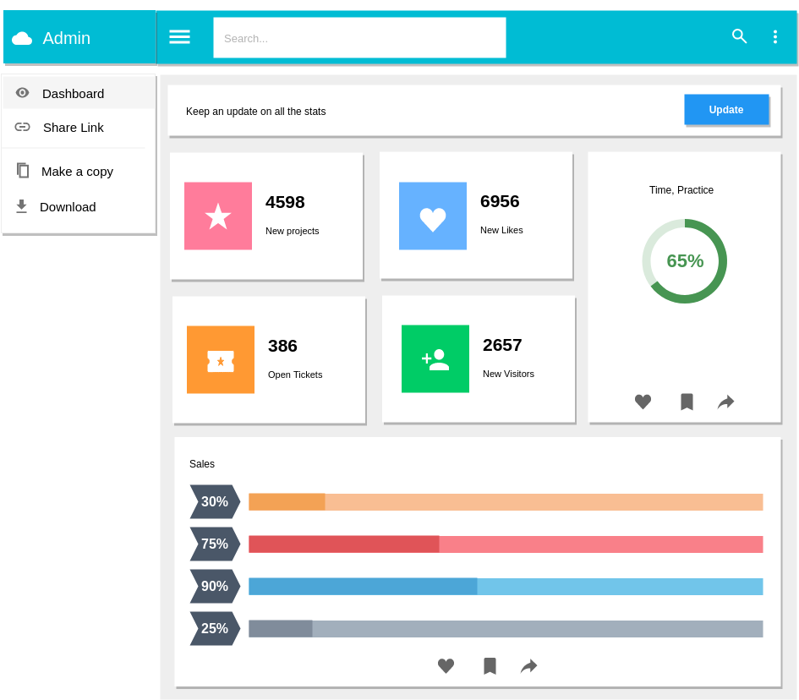
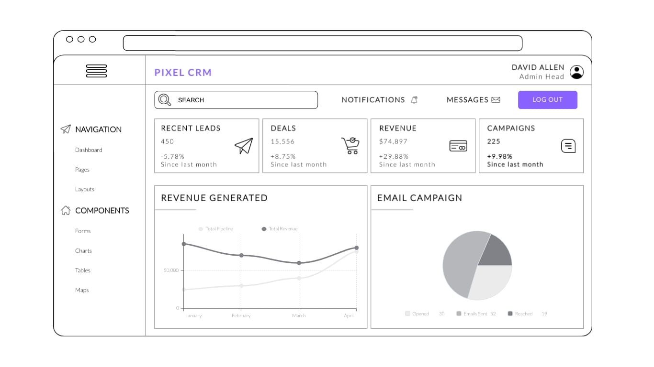

Layout Wireframe
------------------------------------------------
| Admin Panel |
------------------------------------------------
| Users | Providers | Complaints | Analytics |
------------------------------------------------
| Total Users: 1200 |
| Active Complaints: 87 |
| Providers Online: 24 |
------------------------------------------------
| Recent Complaints Table |
------------------------------------------------

Purpose
- System monitoring
- Control & analytics

Backend Dependency
✔ /api/admin/overview
✔ /api/admin/users

8. Profile Page (All Roles)
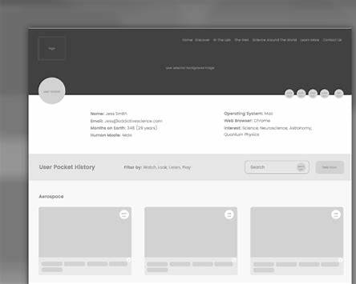

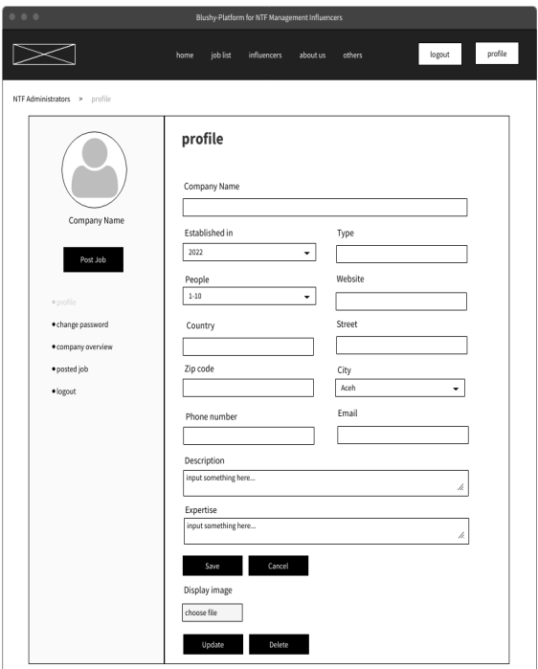

Layout Wireframe
------------------------------
| Profile Details |
------------------------------
| Name |
| Email |
| Role |
| Location |
| |
| [ Edit Profile ] |
------------------------------

Purpose
- Account management
- Profile updates

Backend Dependency
✔ /api/profile/update

9. Navigation Flow (For Viva Explanation)
Landing
↓
Login / Register
↓
Role-based Dashboard
↓
Create / Manage Requests
↓
Track Status / Analytics

10. Why These Wireframes Are Perfect for Your Project
✔ Simple (no UI clutter)
✔ Easy to convert into HTML/CSS
✔ Covers all use cases from your ER diagram
✔ Looks professional in project report
✔ Easy to explain in viva

